

**DRIVER LICENSE EXAM SUPPORT Software Requirement Specification**

**Report 4 - Functional Requirements**

– HoChiMinh, August 2022 –

**Table of Contents**

Record of Changes 2

IV. Functional Requirements 4

1. System Functional Overview 4

1.1 Screen Flow 4

1.2 Screen Descriptions 5

1.3 Screen Authorization 5

1.4 Non-Screen Functions 6

2. Data Requirements 6

2.1 Logical Data Model 6

2.2 Data Dictionary 7

2.3 Reports 8

2.4 State transition diagram 10

3. Manage Account 11

3.1 View Account List 11

3.2 Add Account 11

3.3 Edit Account 12

4. Manage Warehouse Tag 12

4.1 View List of Warehouse Tags 12

4.2 Add Warehouse Tag 13

4.3 Edit Warehouse Tag 13

5. Transaction 14

5.1 Import 14

5.2 Export 14

6. Search Information 15

7. View Report 15

# Record of Changes

|  |  |  |  |
| --- | --- | --- | --- |
| **Date** | **A* M, D** | **In charge** | **Change Description** |
|  |  |  |  |
|  |  |  |  |
|  |  |  |  |
|  |  |  |  |
|  |  |  |  |
|  |  |  |  |
|  |  |  |  |
|  |  |  |  |
|  |  |  |  |
|  |  |  |  |
|  |  |  |  |
|  |  |  |  |
|  |  |  |  |

*A - Added M - Modified D - Deleted

# IV. Functional Requirements

## 1. System Functional Overview

In the warehouse for the restaurant system, the Manager, warehouse keeper must login to use this system. It divides the user in many roles to correspond to the function they can use. For example, only the admin role can edit the account in another role, only the warehouse keeper can report information to the manager. There are many functions show on the UI. In navigation, the manager can manage the warehouse keeper, watch report, material category, In the body, this system show details of material: number; status of material: in stock or out stock; import or export information, …

### 1.1 Screen Flow

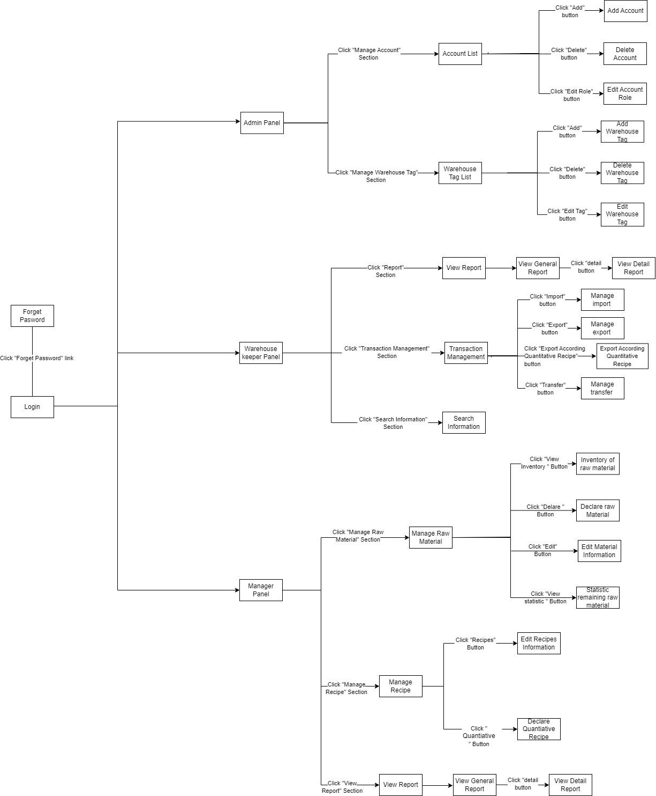

### 1.2 Screen Descriptions

|  |  |  |  |
| --- | --- | --- | --- |
| **#** | **Screen** | **Feature** | **Description** |
| FR-01 | Login | Login | Login into the system, the system will check the role of the account and then send that account to the true screen. |
| FR-02 | Forget Password | Login | Manager can change the password if forgot it. |
| FR-03 | Account List | Manage Account | List of accounts |
| FR-04 | Add Account | Manage Account | Adding new account |
| FR-05 | Delete Account | Manage Account | Removing account from list |
| FR-06 | Edit Account role | Manage Account | Changing /Editing role for member |
| FR-07 | Warehouse Tag List | Manage Warehouse Tag | List of warehouse tags |
| FR-08 | Add Warehouse Tag | Manage Warehouse Tag | Adding new warehouse tag |
| FR-09 | Delete Warehouse Tag | Manage Warehouse Tag | Removing warehouse tag from list |
| FR-10 | Edit Warehouse Tag | Manage Warehouse Tag | Changing /Updating warehouse tag’s information |
| FR-11 | General Report | View Report | Viewing data summary |
| FR-12 | Detailed Report | View Report | Viewing detailed data |
| FR-13 | Manage Import | Transaction | Inputting/Viewing information from goods received note |
| FR-14 | Manage Export | Transaction | Inputting/Viewing information from goods delivered note |
| FR-15 | Manage Transfer | Transaction | Inputting/Viewing information from goods transfer note |
| FR-16 | Exporting According Quantitative Recipe | Transaction | Inputting/Viewing information according to quantitative recipe to export |
| FR-17 | Inventory Of Raw Material | Manage Raw Material | Checking detailed raw materials in warehouse |
| FR-18 | Statistic Remaining Raw Material | Manage Raw Material | Checking raw material summary in warehouse |
| FR-19 | Declare Raw Material | Manage Raw Material | Inputting/Adding new raw material |
| FR-20 | Edit Material Information | Manage Raw Material | Changing/Updating material’s information |
| FR-21 | Declare Quantitative Recipe | Manage Recipe | Inputting/Adding new quantitative recipe |
| FR-22 | Edit Recipe Information | Manage Recipe | Changing/Updating recipe’s information |

### 1.3 Screen Authorization

|  |  |  |  |
| --- | --- | --- | --- |
| **Screen** | **Warehouse Keeper** | **Manager** | **Administrator** |
| Login | x | x | x |
| Forget password screen | x | x | x |
| Account List |  |  | x |
| Warehouse Tag List |  |  | x |
| View Report | x | x |  |
| View Detail Report | x | x |  |
| Manage Import | x | x |  |
| Manage Export | x | x |  |
| Manage Transfer | x | x |  |
| Search Information | x | x |  |
| Add Account |  |  | x |
| Delete Account |  |  | x |
| Edit Account Role |  |  | x |
| Add Warehouse Tag |  |  | x |
| Delete Warehouse Tag |  |  | x |
| Edit Warehouse Tag |  |  | x |
| Inventory Of Raw Material | x | x |  |
| Delare Raw Material |  | x |  |
| Edit Material Information |  | x |  |
| Statistic Remaining Raw Material | x | x |  |
| Edit Recipe Information |  | x |  |
| Delare Quantitative Recipe |  | x |  |

In which:

* Warehouse Keeper: The warehouse keeper is responsible for performing the receiving, processing, storing and dispatching of inventory according to purchase orders and shipping schedules. Their duties include placing orders, declaring raw materials, inventorying each warehouse and reporting on warehouse management software for restaurants.
* Manager: A warehouse operations manager oversees the entire distribution plan of a business and manages warehouse operations by planning, dispatching, order management, and reporting on the software.
* Administrator: Administrator is the person who can operate, customize the content of the system and manage user information.

### 1.4 Non-Screen Functions

|  |  |  |  |
| --- | --- | --- | --- |
| **#** | **System Function** | **Feature** | **Description** |
|  |  |  |  |
|  |  |  |  |

## 

## 2. Data Requirements

### 2.1 Logical Data Model

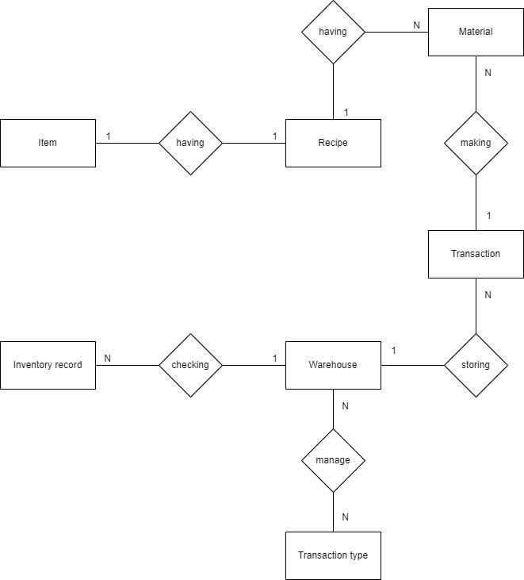

### 2.2 Data Dictionary

|  |  |  |  |  |
| --- | --- | --- | --- | --- |
| **Data Element** | **Description** | **Composition or Data Type** | **Length** | **Values** |
| Materials | Which is to make foods/drinks | Material name  + Material ID  +Description  + Material price  + Quantity  + Category |  |  |
| Category | Type of material | Alphabetic | 20 |  |
| Quantity | The number of materials | Integer | 4 | Default = 1; maximum = quantity presently in inventory |
| Description | Showing more detailed information | Alphanumeric | 100 | Commas permitted |
| Material ID | Unique ID to determine material | Alphanumeric | 10 |  |
| Transaction | Where materials are to be imported , exported | Location name  + Import location  + Export location  + Transaction date |  |  |
| Import location | A place materials are imported | Alphanumeric | 100 | Slashes and commas permitted |
| Export location | A place materials are exported | Alphanumeric | 100 | Slashes and commas permitted |
| Transaction date | The date materials are imported , exported | Date, MM/DD/YYYY |  |  |
| Warehouse | A place materials are stored | Warehouse name  + 1:N{Inventory record}  + 1:1{Transaction}  +N:N{Transaction type} |  |  |
| Item price | Cost of item | Numeric,vnđ | dd.cc |  |
| Material price | Cost of material | Numeric,vnđ | dd.cc |  |
| Recipe | A tutorial how to make food/drink | Recipe name  +1:N{Material}  +Tools  +Description | 200 | Commas permitted |
| Item | A finished product | Item name  +1:1{Recipe}  +Item price |  |  |
| Inventory record | A note is used to checked materials in warehouse | Inventory record ID  +Transaction date  +Description  +Material ID  +Quantity  +Material price |  |  |
| Transaction type | Import/export/transfer from internal or outside | Status  +N:N{Warehouse} |  |  |

### 2.3 Reports

|  |  |  |
| --- | --- | --- |
| **#** | **Report Name** | **Description** |
| RPT-01 | General report |  |
| RPT-02 | Detailed report |  |

|  |  |
| --- | --- |
| Report ID: | RPT-01 |
| Report Title: | General report |
| Report Purpose: | Warehouse keeper wants to check a list of materials that he/she had previously imported/exported over a specified time period up to three months prior to the current date. |
| Priority: | Medium |
| Report Users: | Warehouse keeper |
| Data Sources: | Database of previously placed transaction |
| Frequency and Disposition; | Report is generated on demand by a warehouse keeper. Data in the report is static. Report is displayed on the warehouse keeper's web browser screen on a computer, tablet, or smartphone. It can be printed if the display device permits printing. |
| Latency: | Complete report must be displayed to the warehouse keeper within 3 seconds after it is requested. |
| Visual Layout: | Landscape mode |
| Header and Footer: | Report header shall contain the report title, warehouse keeper's name, and date range specified. If printed, the report footer shall show the page number. |
| Report Body: | Fields shown and column headings:   * Delivery Bill * Material ID * Material Name * Type * Tax * Quantity * Material price * Total Price |
| End-of-Report Indicator: | None |
| Interactivity: | Warehouse keeper can drill down to see ingredients and information for each item in the order |
| Security Access Restrictions: | A warehouse keeper may retrieve only his own report history |

|  |  |
| --- | --- |
| Report ID: | RPT-02 |
| Report Title: | Detailed report |
| Report Purpose: | Warehouse keeper wants to check a list of materials that he/she had previously imported/exported over a specified time period up to three months prior to the current date. |
| Priority: | Medium |
| Report Users: | Warehouse keeper |
| Data Sources: | Database of previously placed transaction |
| Frequency and Disposition; | Report is generated on demand by a warehouse keeper. Data in the report is static. Report is displayed on the warehouse keeper's web browser screen on a computer, tablet, or smartphone. It can be printed if the display device permits printing. |
| Latency: | Complete report must be displayed to the warehouse keeper within 3 seconds after it is requested. |
| Visual Layout: | Landscape mode |
| Header and Footer: | Report header shall contain the report title, warehouse keeper's name, and date range specified. If printed, the report footer shall show the page number. |
| Report Body: | Fields shown and column headings:   * Delivery Bill * Date * Material ID * Material Name * Type * Description * Tax * Quantity * Material price * Total Price |
| End-of-Report Indicator: | None |
| Interactivity: | Warehouse keeper can drill down to see ingredients and information for each item in the order |
| Security Access Restrictions: | A warehouse keeper may retrieve only his own report history |

### 2.4 State transition diagram

### 2.4.1 Import

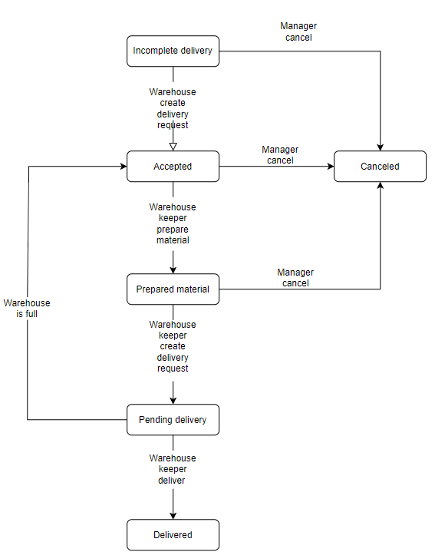

### 2.4.2 Export

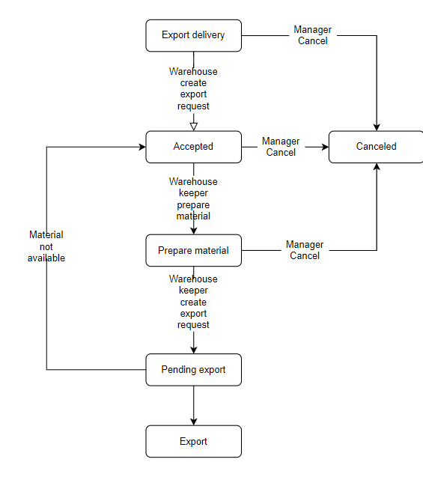

## 

## 

## 

## 

## 3. Login

Function Trigger:This function triggers when the member clicks “**Login**”.

Function Description:This function allows a member to login into the system.

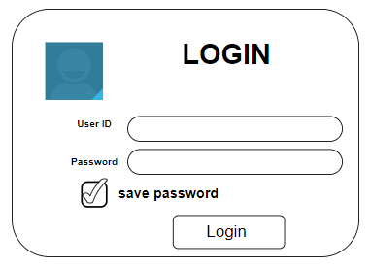

Function Details:

* Member input User ID and password to login.
* WRS will check the role after a member clicks “**Login**” and go to the screen corresponding to that role.

## 4. Admin Panel

Function Trigger: This function triggers after the member login by Admin account.

Function Description: This feature shows Admin menu.

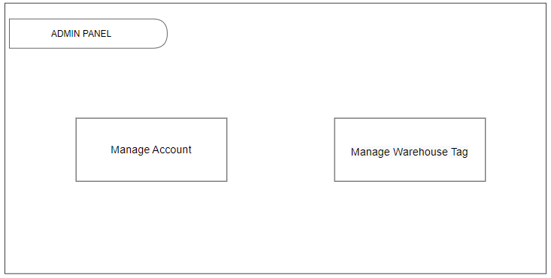

Function Details:

* When the admin clicks “**Manage Account**” the system will go to the screen function “Manage Account”.
* When the admin clicks “**Manage Warehouse Tag**” the system will go to the screen function “Manage Warehouse Tag”.
* Admin wants to return to the function selection screen, admin can click “**Admin Panel**”.

## 5. Manage Account

### 5.1 View Account List

Function Trigger: This function triggers after the admin clicks on “**Manage Account**”.

Function Description: This feature allows the admin to view accounts detail.

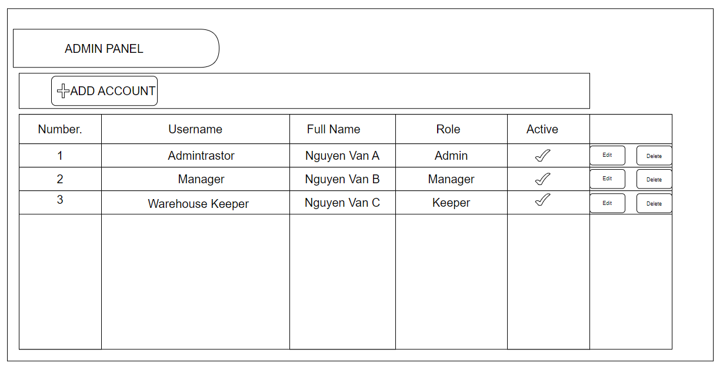

Function Details:

* Admin can view account information (Name, role...).
* When the admin clicks “**Add Account**” the system will go to the screen function “Add Account”.
* When the admin clicks “**Edit**” the system will go to the screen function “Edit Account”.
* When the admin clicks “**Delete**” the system will go to the screen function “Delete Account”.

### 5.2 Add Account

Function Trigger: This function triggers after the admin clicks on “**Add Account**” in the View Account List.

Function Description: This feature allows the admin to add members to WRS.

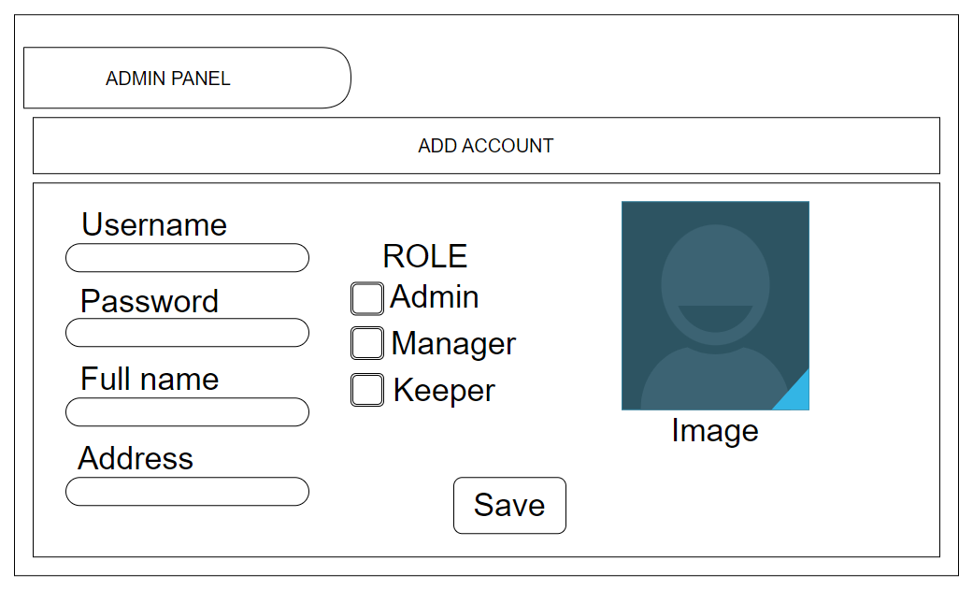

Function Details:

* Admin can add member’s information (Name, role...) to WRS.
* Admin clicks “**Save**” and the system will save member’s information to the database.
* Function will return to the screen “**View Account List**”.

### 

### 5.3 Edit Account

Function Trigger: This function triggers after the admin clicks on “**Edit”** in the View Account List**.**

Function Description: This feature is used to change a member's role.

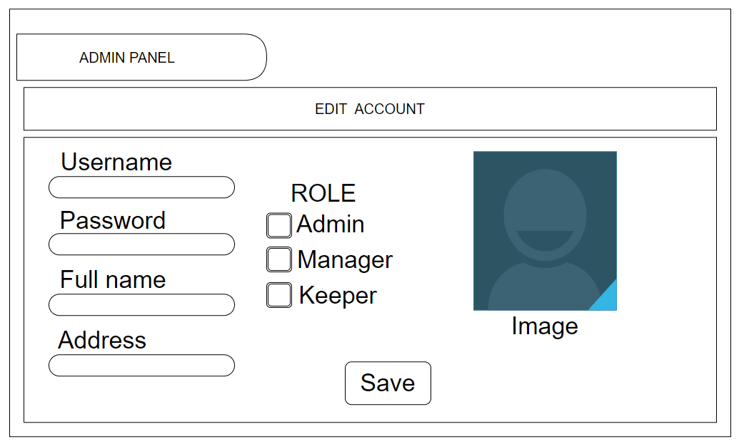

Function Details:

* Admin can edit member’s information (Name, role...).
* Admin clicks “**Save**” and the system will save member’s information to the database.
* Function will return to the screen “**View Account List**”.

### 

### 5.4 Delete Account

Function Trigger: This function triggers after the admin clicks on “**Delete**” in the View Account List.

Function Description: This feature is used to delete a member account.

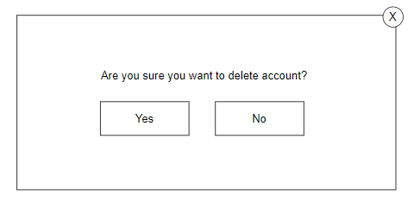

Function Details:

* Admin clicks “**Yes**” and the system will delete the member account from the database.
* Admin clicks “**No**” and the function will return to the screen “**View Account List**”.

## 6. Manage Warehouse Tag

### 6.1 View List of Warehouse Tags

Function Trigger: This function triggers after the admin clicks on “**Manage Warehouse Tags**”.

Function Description: This feature allows the admin to view a list of warehouse tags.

### 

Function Details:

* Admin can view a list of warehouse tags.
* When the admin clicks “**Add Warehouse Tag**” the system will go to the screen function “Add Warehouse Tag”.
* When the admin clicks “**Edit**” the system will go to the screen function “Edit Warehouse Tag”.
* When the admin clicks “**Delete**” the system will go to the screen function “Delete Warehouse Tag”.

### 6.2 Add Warehouse Tag

Function Trigger: This function triggers after the admin clicks on “**Add**” in the View List of Warehouse Tags.

Function Description: This feature allows the admin to add warehouse tags.

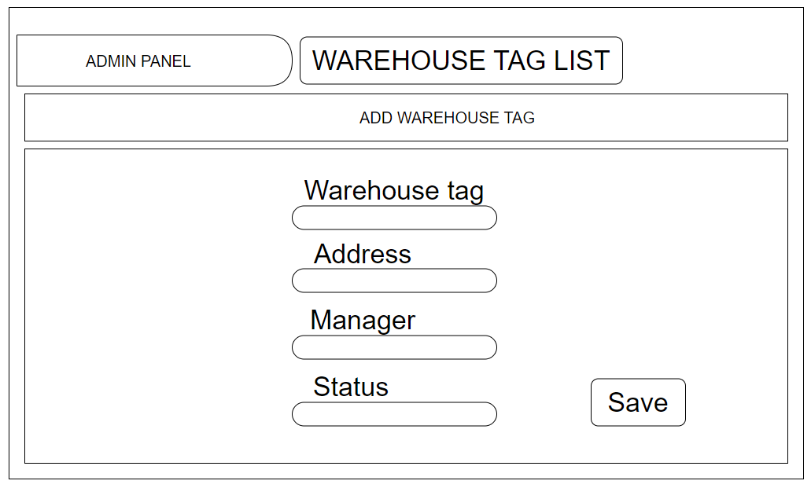

Function Details:

* Admin can add warehouse tag information (Tag, address...)
* Admin clicks “**Save**” and the system will save warehouse tags information to the database.
* Function will return to the screen “**View List of Warehouse Tags**”.

### 6.3 Edit Warehouse Tag

Function Trigger: This function triggers after the admin clicks on “**Edit”** in the View List of Warehouse Tags.

Function Description: This feature allows the admin to edit warehouse tags.

## 

Function Details:

* Admin can edit warehouse tag information (Tag, address...)
* Admin clicks “**Save**” and the system will save warehouse tags information to the database.
* Function will return to the screen “**View List of Warehouse Tags**”.

### 6.4 Delete Warehouse Tag

Function Trigger: This function triggers after the admin clicks on “**Delete”** in the View List of Warehouse Tags.

Function Description: This feature allows the admin to delete warehouse tags.

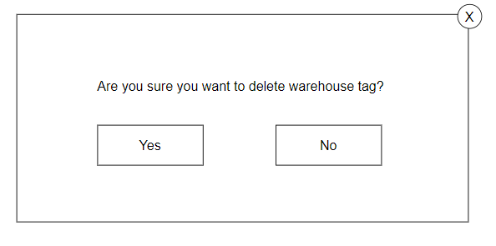

Function Details:

* Admin clicks “**Yes**” and the system will delete the warehouse tag from the database.
* Admin clicks “**No**” and the function will return to the screen “**View List of Warehouse Tags**”.

## 

## 7. Warehouse Keeper Panel

Function Trigger: This function triggers after member login by Warehouse keeper account.

Function Description: This feature shows the Warehouse Keeper menu.

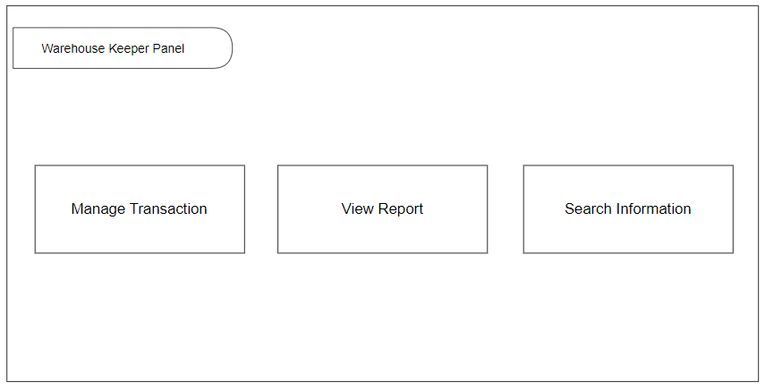

Function Details:

* When the warehouse keeper clicks “**Manage Transaction**” the system will go to the screen function “Manage Transaction”.
* When the warehouse keeper clicks “**View Report**” the system will go to the screen function “View Report”.
* When the warehouse keeper clicks “**Search Information**” the system will go to the screen function “Search Information”.
* Warehouse keeper wants to return to the function selection screen, warehouse keeper can click “**Warehouse Keeper Panel**”.

## 8. Manage Transaction

### 8.1 Manage Transaction

Function Trigger: This function triggers when the warehouse keeper clicks on “**Manage Transaction**”.

Function Description: This feature shows the Transaction menu for the warehouse keeper.

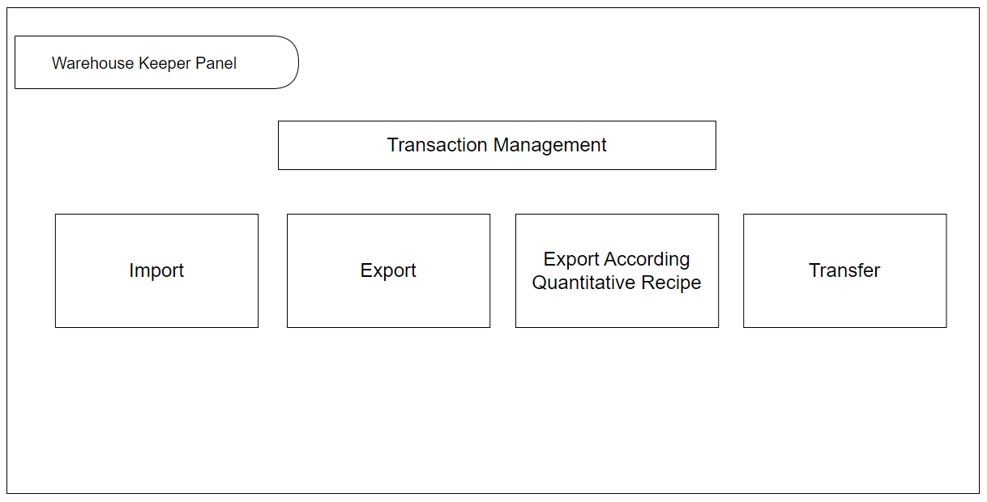

Function Details:

* When the warehouse keeper clicks “**Import**” the system will go to the screen function “Import”.
* When the warehouse keeper clicks “**Export**” the system will go to the screen function “Export”.
* When the warehouse keeper clicks “**Export According Quantitative Recipe**” the system will go to the screen function “ Export According Quantitative Recipe”.
* When the warehouse keeper clicks “**Transfer**” the system will go to the screen function “Transfer”.
* Warehouse keeper wants to return to the function selection screen, warehouse keeper can click “**Warehouse Keeper Panel**”.

### 

### 8.2 Import

Function Trigger: This function triggers after the warehouse keeper clicks on “**Import**”.

Function Description: This feature allows warehouse keepers to import material into the warehouse.

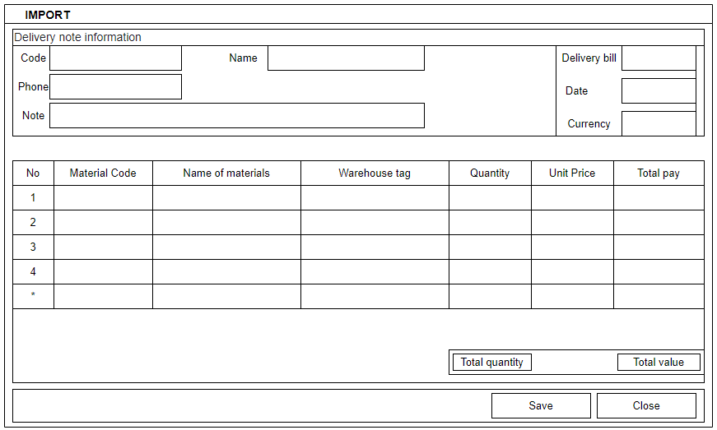

Function Details:

* Warehouse keepers can add import information.
* When the warehouse keeper clicks “**Save**” the system will save import information to the database.
* When the warehouse keeper clicks “**Close**” the system will return to the screen function “**Manage Transaction**”.

### 8.3 Export

Function Trigger: This function triggers after the warehouse keeper clicks on “**Export**”.

Function Description: This feature allows warehouse keepers to export material.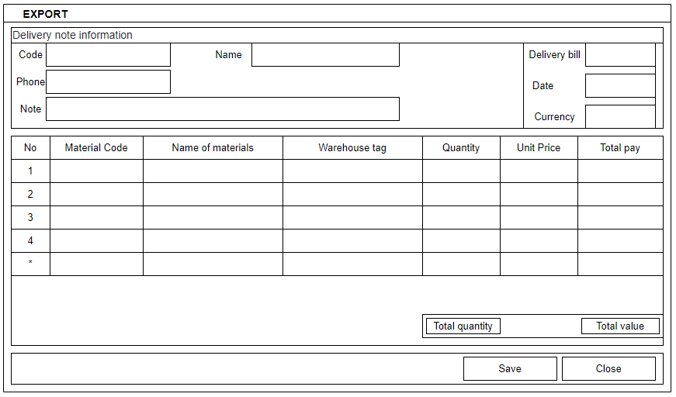

Function Details:

* Warehouse keeper can add export information
* When warehouse keeper click “**Save**” the system will save export information to database
* When warehouse keeper click “**Close**” the system will return to screen function “**Manage Transaction**”

### 

### 8.4 Transfer

Function Trigger: This function triggers after the warehouse keeper clicks on “**Transfer**”.

Function Description: This feature allows warehouse keepers to transfer material.

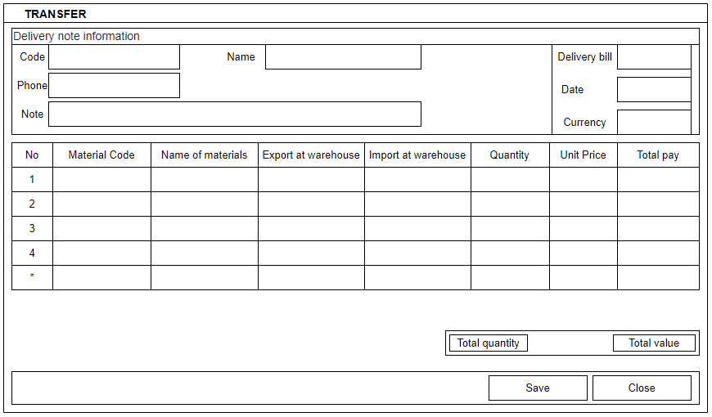

Function Details:

* Warehouse keeper can add transfer information
* When warehouse keeper click “**Save**” the system will save transfer information to database
* When warehouse keeper click “**Close**” the system will return to screen function “**Manage Transaction**”

## 9. View Report

### 9.1 General Report

Function Trigger: This function triggers after warehouse keeper clicks on “**View Report**”

Function Description: This feature is used to view reports.

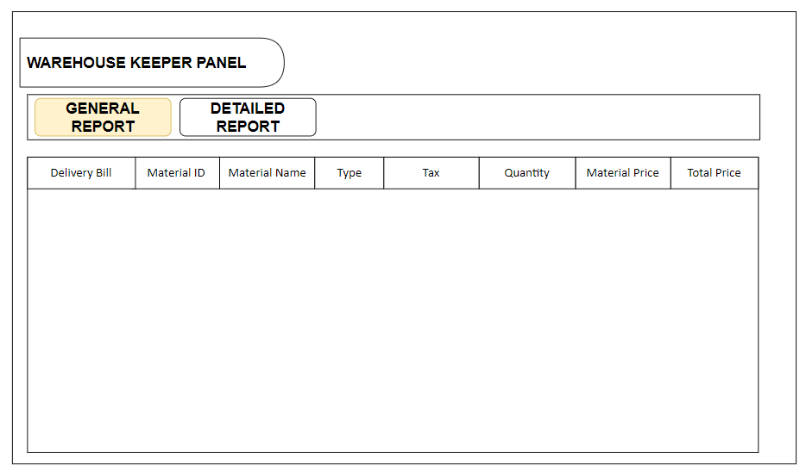

Function Details:

* Warehouse keeper can view the general report.
* When the warehouse keeper clicks “**Detailed Report**” the system will go to the screen function “**Detailed Report**”.

### 

### 9.2 Detailed Report

Function Trigger: This function triggers after warehouse keeper clicks on “**View Report**”

Function Description: This feature is used to view reports.

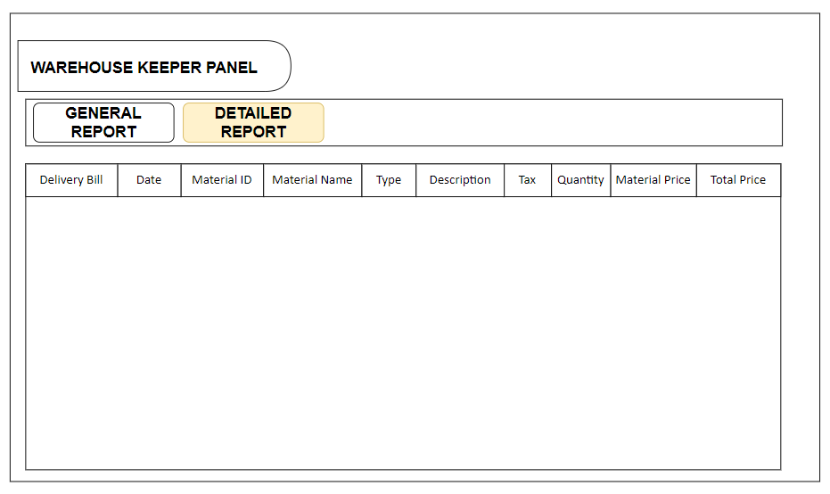

Function Details:

* Warehouse keeper can view the detailed report.
* When the warehouse keeper clicks “**General Report**” the system will go to the screen function “**General Report**”.

## 10. Search Information

Function Trigger: This function is triggered after user clicks on “**Search”**

Function Description: This feature is used to search for information on import and export, transfers, warehouse tags.

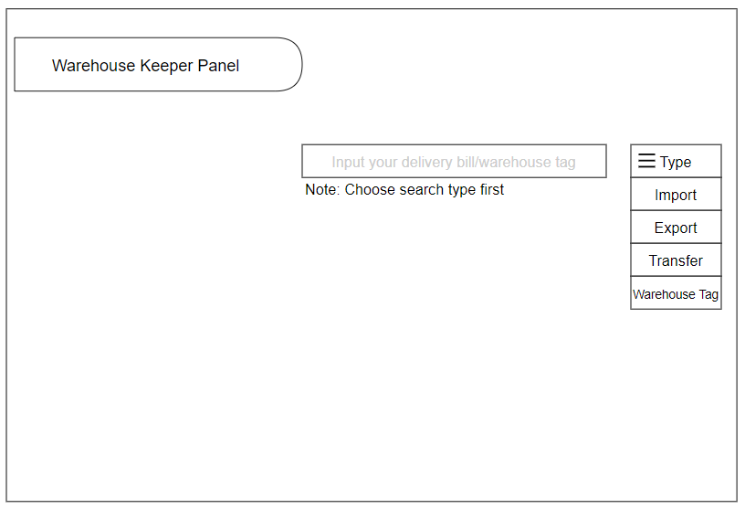

Function Details:

+Warehouse keeper/manager choose search type first after that they will input information of that type to search for information.

## 11. Manager Panel

Function Trigger:This function trigger when user login by Manager account

Function Description:This feature show Manager menu for user

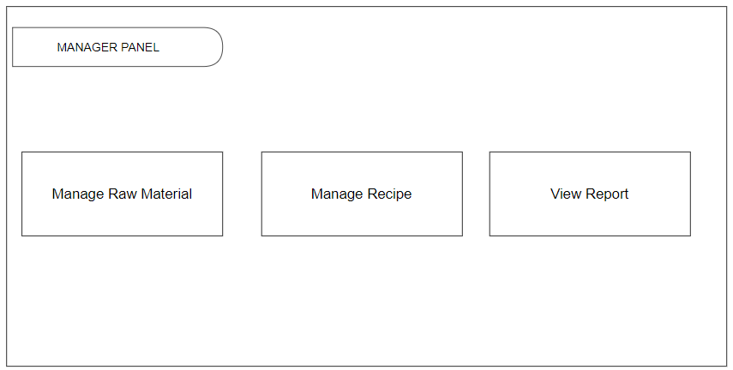

Function Details:

+ When the manager clicks “**Manage Raw Material**” the system will go to the screen function “Manage Raw Material”.

+ When the manager clicks “**Manage Recipe**” the system will go to the screen function “Manage Recipe”.

+ When the manager clicks “**View Report**” the system will go to the screen function “View Report”.

## 12. Manage Raw Material

### 12.1 Inventory of raw material

Function Trigger: This function trigger when user clicks on “Inventory of Raw Material”

Function Description: This feature shows Inventory of raw material information.

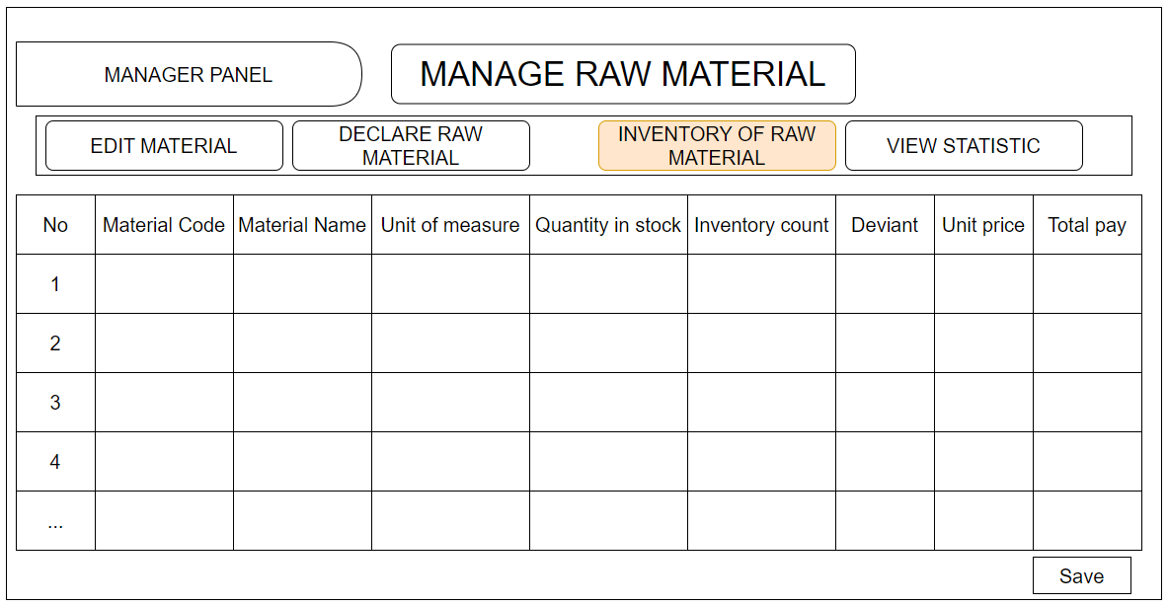

Function Details:

* Material Code: ID of material
* Material Name: Name of material
* Unit of measure: type of measure
* Quantity in stock: Number of quantity available
* Inventory count:
* Deviant:
* Unit price: Price per 1 Unit
* Total pay: total price
* Save: Save the information to database

### 12.2 Declare raw Material

Function Trigger: This function trigger when user clicks on “Declare raw Material”

Function Description: This feature is used to declare new material

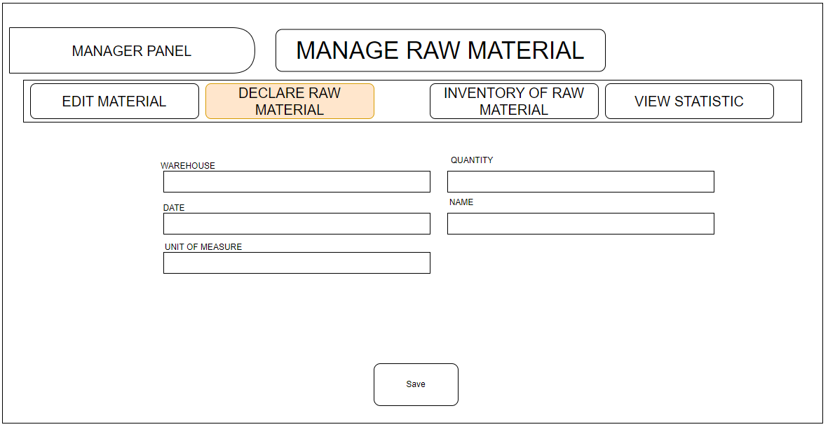

Function Details:

* Warehouse: ID of the warehouse where the material is stored
* Quantity: Quantity of material
* Date: Date declare
* Name: Material Name
* Unit of Measure: Type of measure
* Save: Save information to database

### 12.3 Edit Material Information

Function Trigger: This function trigger when user click on “Edit Material”

Function Description: This feature is used to edit material information

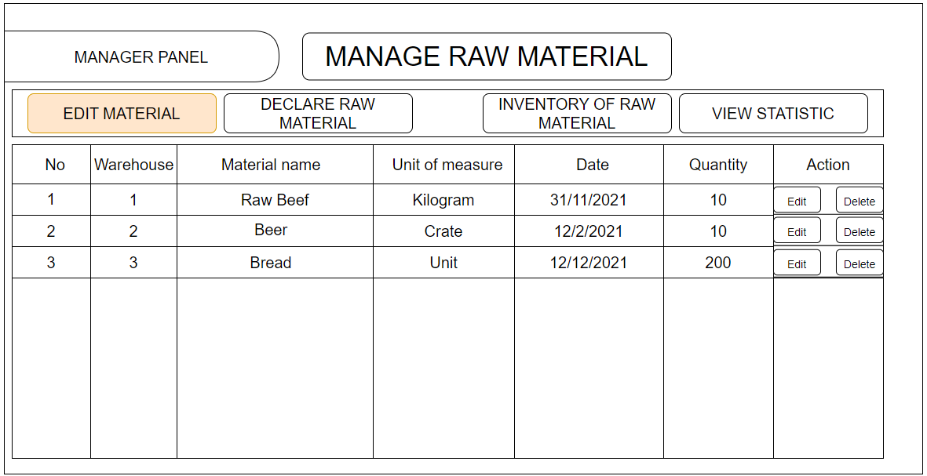

Function Details:

+No: Material ID

+Warehouse: Warehouse ID

+Material name: Material name

+Unit of measure: Type of measure

+Date: Edit date

+Quantity: Quantity of material

+Action:

* Edit: Allow user to edit each raw material
* Delete: Allow user to delete each raw material

### 12.4 Statistic remaining raw material

Function Trigger: This function trigger when user clicks on **“View Statistic”**

Function Description: This feature shows statistic of material

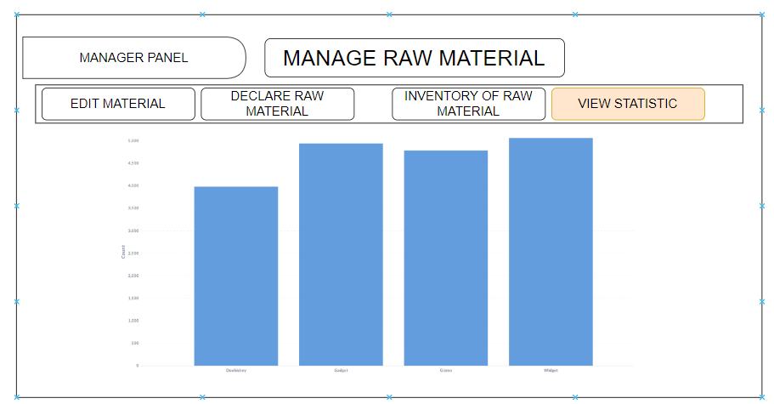

Function Details:

+

## 13. Manage Recipe

### 13.1 Edit Recipes Information

Function Trigger:This function trigger when user clicks on “Manage Recipes”

Function Description: This feature show list of recipes

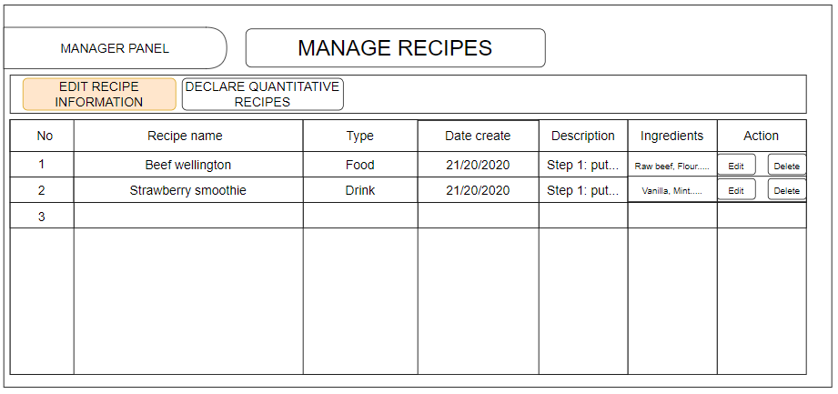

Function Details:

+Recipe name: Name of recipe

+Type: Recipe type (ex: food, drink..)

+Date create: Create day of recipe

+Description: Description for the recipe

+Ingredients: Quantitative of each material

+Action:

* Edit: Allow user to edit each recipe
* Delete: Allow user to delete each recipe

### 13.2 Declare Quantitative Recipe

Function Trigger: This function trigger when User click on “Declare quantitative recipes”

Function Description: this feature allows user to declare recipe quantitative

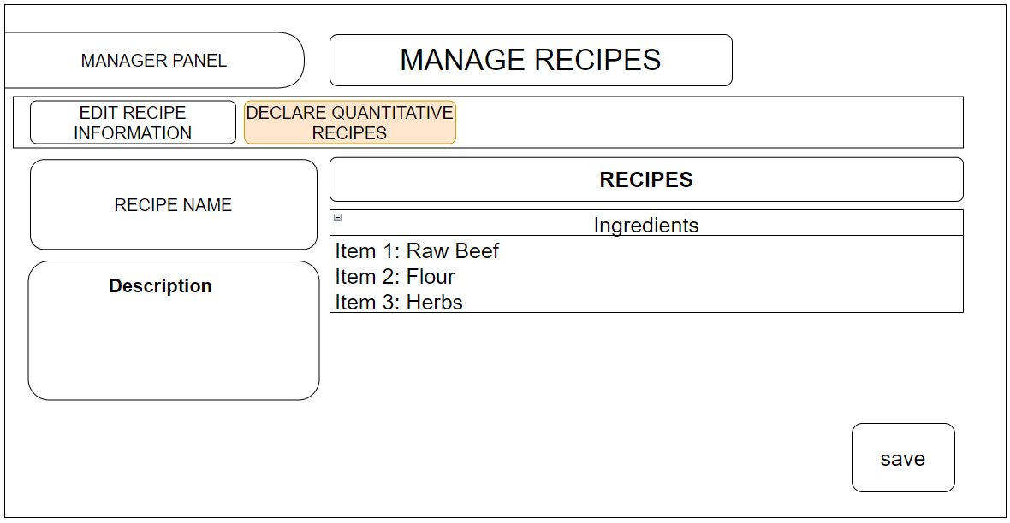

Function Details:

+Recipe name: user input name of the recipe

+Description: User input description for each recipe

+Ingredients: user input ingredient for each recipe

+Save: save information to the database